



SHANGHAI MARITIME UNIVERSITY

**Cinema ticketing system based on Node.js**

**Course Name: Software Project Management**

**Instructor: Liu Jin**

**Members : Wang Wenjing 202230310283**

**Member : Pan Jiaqi 202230310280**

**Member : Chen Minghui 202230310243**

**Date : 2023.06.01**

**Contents**

1. Introduction 1

2. System implementation 1

2.1 Introduction to the tool 1

2.2 Functional modules 2

2.3 Server Design 3

2.4 Database design 3

3. System detailed design 4

3.1 Mini Program homepage 4

3.2 Mini Program Address Page 6

3.3 Mini Program discovery page 8

3.4 Mini Program My Page 9

4. Organization chart 12

5. Item lifetime 14

6. Project cost control and Gantt charts 16

7. Summary 16

**1. Introduction**

This project aims to develop a simple cinema ticketing system. With the continuous improvement of people's living standards, people's lifestyles are no longer limited to the improvement of ordinary clothing, food, housing, transportation and other material aspects, but also pursue a qualitative mutation in the spiritual aspect. As a result, people increasingly choose to watch a movie with three or two friends on weekends or holidays to enjoy free time and release stress. In response to this demand of the public, many movie ticket purchase mini programs were born.

For the cinema management department, ticket booking is the most basic business in all business, on the surface, it is only a simple part of the cinema business, but it involves management and customer service and many other aspects. However, in the past, the traditional way of purchasing tickets in cinemas can no longer meet everyone's requirements, which requires a new way to purchase tickets - online tickets, to relieve the pressure of peak periods and provide users with convenient and fast ways to purchase tickets.

Starting from the market demand and the current situation of cinema information service management, based on the analysis of WeChat developer tools and MySQL relational database management system, lightweight and efficient Node .js and WeChat developer tools are selected to realize front-end and back-end data request response and MySQL service background database design, according to the overall architecture, user interface design, database design design process, design a set of online ticket service system.

**2. System implementation**

2.1 Introduction to the tool

(1) WeChat Developer Work is a development tool for WeChat Mini Programs officially provided by WeChat, which concentrates functions such as development, debugging, preview, and upload. The WeChat team released WeChat Mini Program Developer Tools, WeChat Mini Program Development Documentation and WeChat Mini Program Design Guide, a new developer tool that integrates functions such as development and debugging, code editing and program publishing, helping developers develop WeChat Mini Programs simply and efficiently.

(2) Node.js is a JavaScript runtime environment based on the Chrome V8 engine, using an event-driven, non-blocking I/O model JavaScript runs on an open platform on the server side.

(3) MySQL is an [open source](https://baike.baidu.com/item/%E5%BC%80%E6%94%BE%E6%BA%90%E4%BB%A3%E7%A0%81) relational database [management](https://baike.baidu.com/item/%E6%95%B0%E6%8D%AE%E5%BA%93%E7%AE%A1%E7%90%86) system (RDBMS), MySQL [database system](https://baike.baidu.com/item/%E6%95%B0%E6%8D%AE%E5%BA%93%E7%B3%BB%E7%BB%9F) Database management is done using the most commonly used database management language, Structured [Query Language](https://baike.baidu.com/item/%E7%BB%93%E6%9E%84%E5%8C%96%E6%9F%A5%E8%AF%A2%E8%AF%AD%E8%A8%80) (SQL).

2.2 Functional modules

The functional modules of the system are mainly divided into four parts: home, address, discovery, and me. This is shown in Figure 1. WeChat users can browse the basic information of recommended movies and movies on the home page, and they can purchase tickets after confirmation. View the address information of the theater on the address page, click the location of the theater that will appear, you can open the navigation software in the mobile phone to view the specific route, and the surrounding basic information. There are clips and basic information about popular movies on the discovery page, and users can watch the clips to determine whether they like the movie or not. My Page performs functions such as Mini Program user login, registration, logout login, and order viewing.

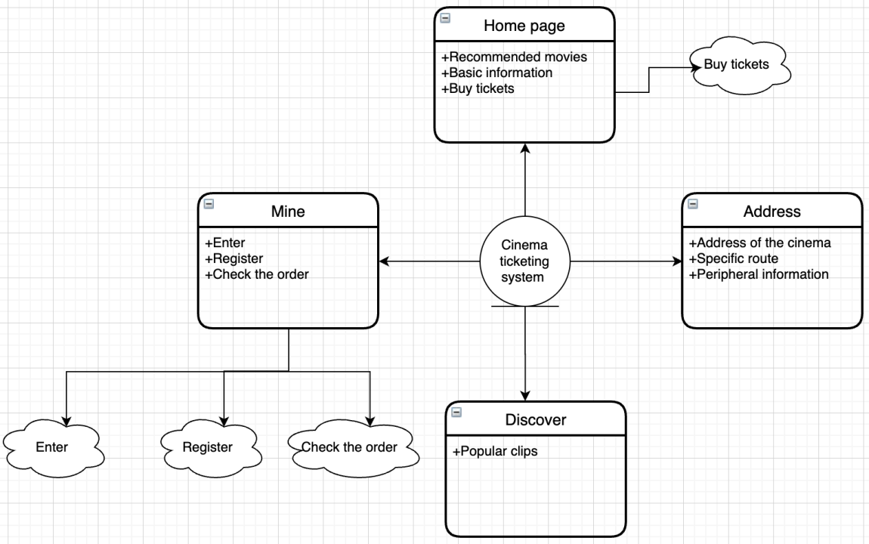

Figure 1 System function module diagram

2.3 Server Design

(1) Accept the front-end request index.js

This is used to process some requests and data sent by the front-end and send these requests to database management.

(2) Database management MySQL .js

This encapsulates some methods to determine what kind of operation is performed on the database: add, delete, modify, and search.

2.4 Database design

The database is composed of multiple data tables, this database uses MySQL to implement and complete the design of the database, including the following in this system: determine the name of all data tables in the database and the name, type, length, primary key and whether the fields contained in the table are empty, etc.

(1) The user table is used to store information about the user, as shown in Table 1

Table 1 User information table

|  |  |  |  |  |  |
| --- | --- | --- | --- | --- | --- |
| number | Field name | Field description | type | Number of digits | attribute |
| 1 | username | User name | varchar | 10 | Required, non-empty, primary key |
| 2 | password | password | varchar | 15 | Required, not blank |
| 3 | nickname | nickname | char | 10 | Required, not blank |
| 4 | phone | Contact number | int | 12 | Required, not blank |
| 5 | sex | gender | char | 10 | Required, not blank |

(2) The movie table (ticket) is used to store information about the movie, as shown in Table 2:

Table 2 Movie Table

|  |  |  |  |  |  |
| --- | --- | --- | --- | --- | --- |
| number | Field name | Field description | type | Number of digits | attribute |
| 1 | id | Movie number | int | 10 | Required, non-empty, primary key |
| 2 | name | Movie name | char | 20 | Required, not blank |

**3. System detailed design**

3.1 Mini Program homepage

Users enter the home page of the Hibiscus Campus Mini Program, can see the home page carousel module, browse recommended movies, and purchase tickets. This is shown in Figures 2 and 3.

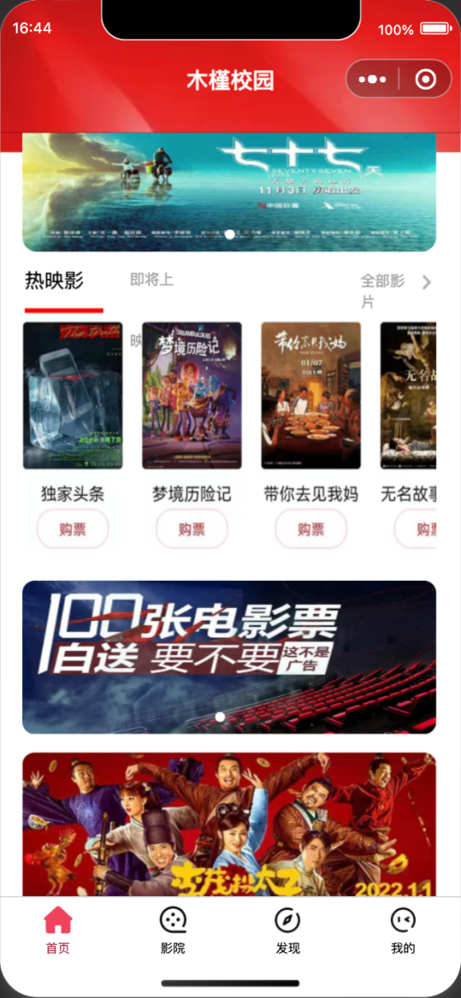

Figure 2: The homepage of the "Hibiscus Campus" WeChat mini program

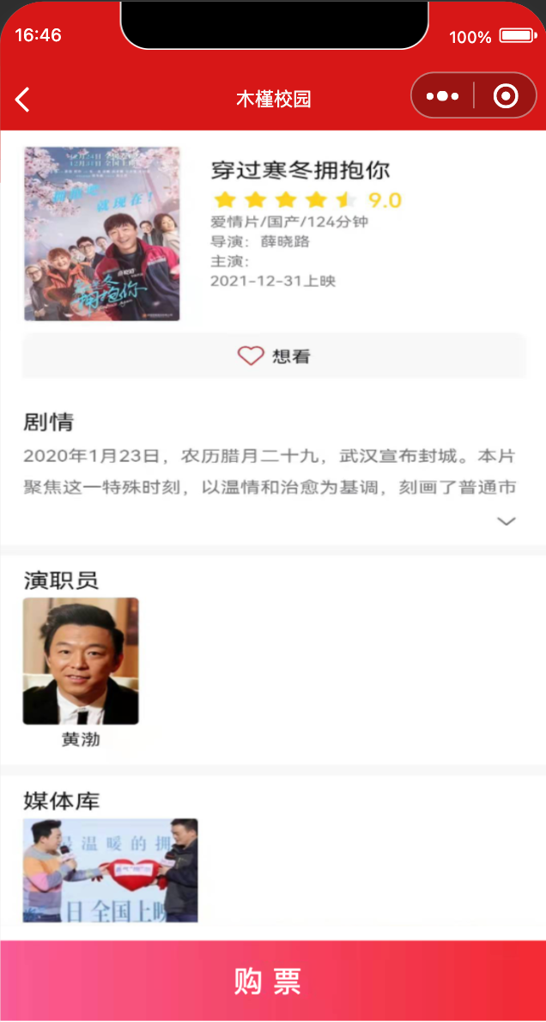

Figure 3 Hibiscus Campus Mini Program ticket purchase page

3.2 Mini Program Address Page

The address page uses the plug-in to obtain the address information of the theater, click on the location of the theater, you can open the navigation software in the mobile phone to view the specific route, and the surrounding basic information. As shown in 4.

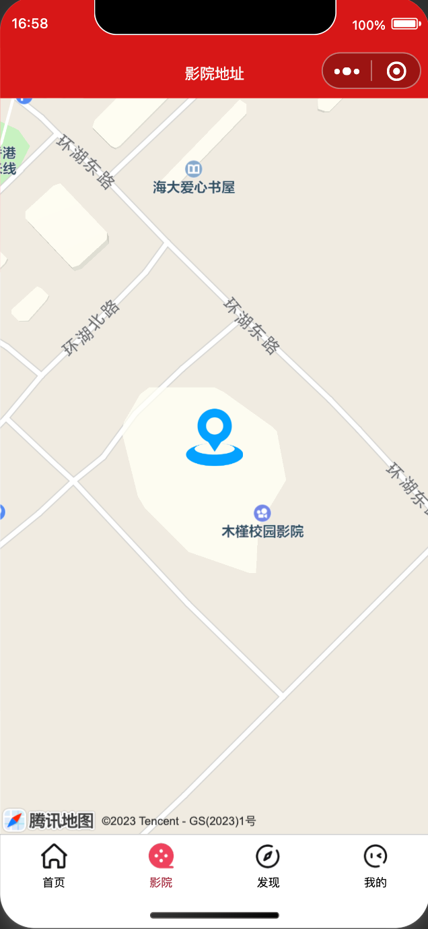

Figure 4 Address page

Click the address button in the middle of the map to transmit the latitude and longitude of the current location to Tencent Map, call the Tencent Maps API to obtain the current geographic location information, and return. This is shown in Figure 5:

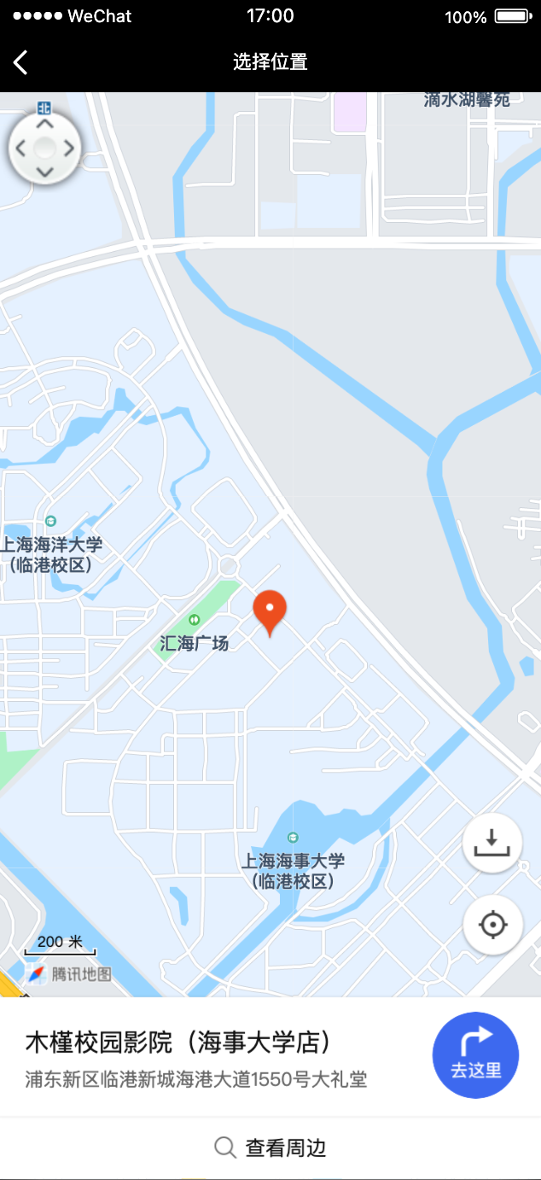

Figure 5: Destination map interface

3.3 Mini Program discovery page

The discovery page contains clips and basic information about popular movies, and users can watch the clips first to determine whether they like the movie or not, and can pause playback. This is shown in Figure 6:

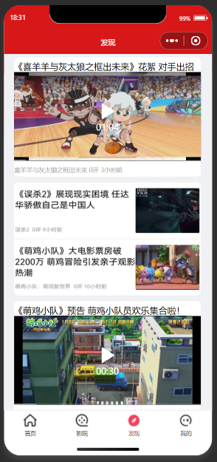

Figure 6: Discovery Interface

3.4 Mini Program My Page

My Page displays Mini Program user login, registration, logout login, order viewing, and nickname information. This is shown in Figure 7:

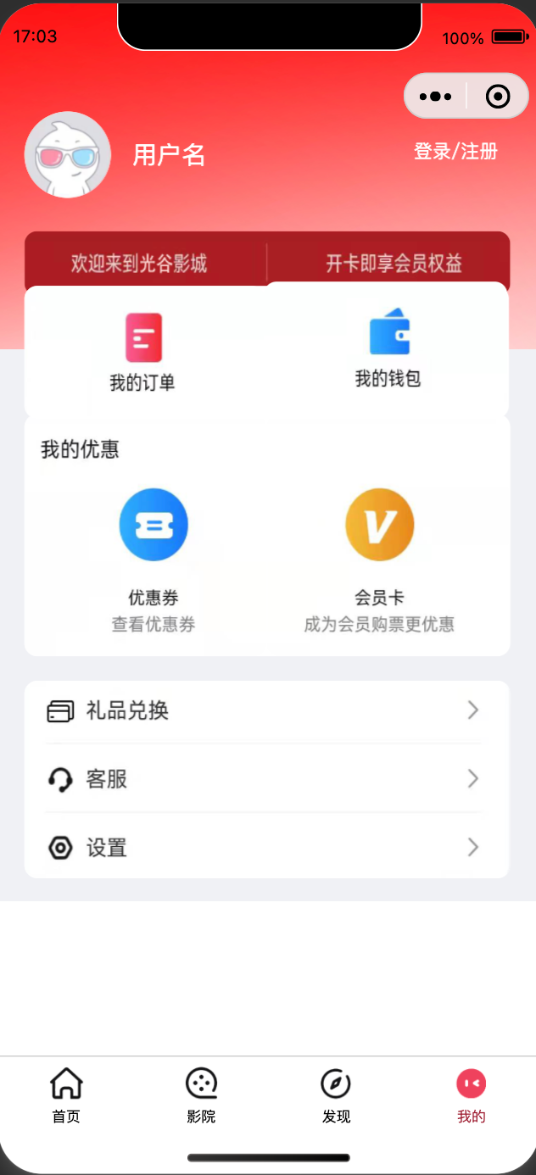

Figure 7 My interface

Click Sign in to register to take you to the login page. This is shown in Figure 8:



Figure 8: Login screen

Clicking Register Now will take you to the registration page. This is shown in Figure 9:

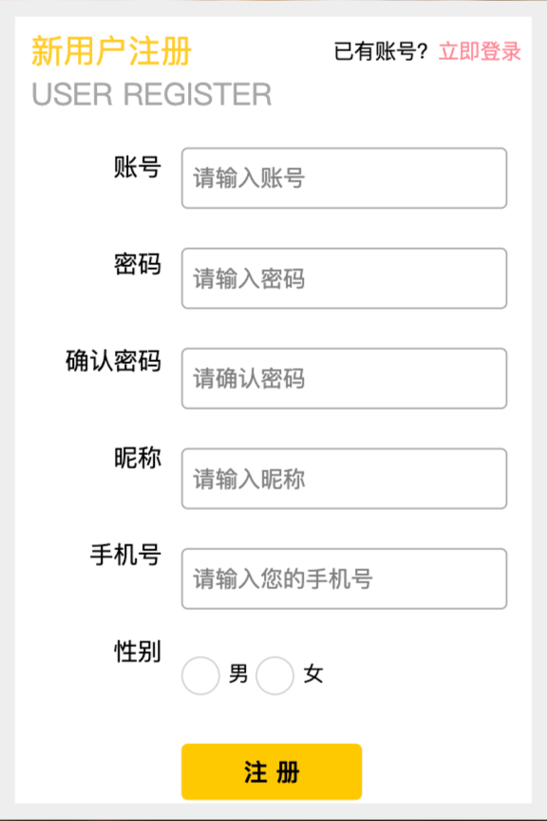

Figure 9: Registration screen

Clicking on My Orders will take you to the Orders page. This is shown in Figure 10:

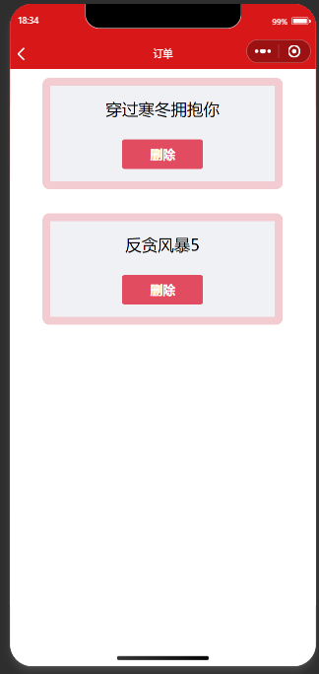

Figure 10 Order screen

**4. Organization chart**

The project organization chart of the "Cinema Ticketing System" is shown in Figure 11, which is a concrete of the matrix organizational structure.

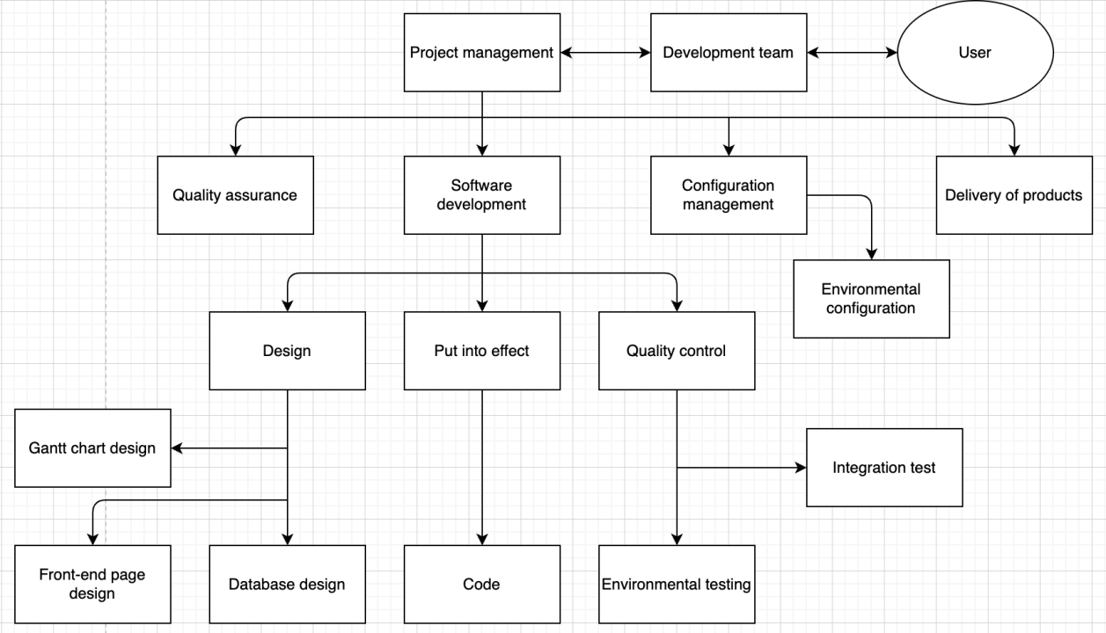

Figure 11 Organization chart

Organizational chart description:

(1) Project management

* Responsible for the organization, implementation and planning of the project
* Responsible for project planning and maintenance
* Responsible for the tracking and management of the project
* Responsible for the allocation of resources and coordination of activities
* Responsible for coordination activities between organizations and programs

(2) Quality assurance

* Responsible for the project process and the formulation of product specifications
* Responsible for the quality assurance activities of project engineering, including process review and product review
* Final review based on the user's needs

(3) Software development

* Responsible for project design, implementation and quality control
* Responsible for the design of the prototype interface
* Responsible for the creation of database tables
* Responsible for the design of the Gantt chart
* Responsible for coding activities for the project implementation process
* Responsible for phased testing and final integration testing

(4) Configuration management

* Responsible for the configuration management activities of the project
* Responsible for the configuration of the development environment, including the development environment, database configuration and server construction
* Responsible for the submission of software products

(5) Users

* Ensure the implementation of relevant responsibilities
* Provide a description of the requirements
* Cooperate with the development team in the implementation of the project
* Participate in the organization and planning of the project
* Responsible for product acceptance

**5. Item lifetime**

The phases in the lifetime are defined as follows:

* Project planning phase

Project Objectives: Determine the scale, timeline and resource requirements of the project according to the project proposal and preliminary needs analysis

Process: project planning, plan confirmation

* Requirements analysis phase

Phase goal: Determine the customer's needs

Process: requirements acquisition, requirements analysis, requirements control

* Design phase

Stage goal: overall system structure design

Process: Overall design

* Phase 1 implementation

Phase goal: Realize the basic configuration of the system

Process: node.js, MySQL, Visual Studio Code environment setup and program installation, and WeChat developer tools ID registration

* Phase 2 implementation

Stage goal: to realize the construction of the basic page of the front-end of the Mini Program

Process: Create the basic framework of the four pages of Home, Theater, Discovery, and Me, as well as the display of relevant information such as movie information, scene arrangement and other related information on the homepage page and the basic layout of My Page

* Phase 3 implementation

Stage goal: Database table creation

Procedure: Create a user information table and a movie table, and add user information and movie ticket information

* Phase 4 implementation

Stage goal: Build a local server

Process: Use Visual Studio Code to set up a local server and connect to the database so that it can access videos and images and set the listening interface

* Phase 5 implementation

Stage goal: Improve the layout of the Mini Program page

Process: Realize the login registration and order viewing function of my page, the ticket purchase function of the home page, and the video playback function of the discovery page

* Phase 6 implementation

Stage goal: Realize the function of mini program theater address

Process: Transmit the latitude and longitude of the destination to Tencent Maps, call the Tencent Maps API to obtain the current geographic location information, and return it

* Integration testing

Phase goal: to pass software testing in an integrated environment

Process: integration test, system test

* Product Submission

Stage goal: the product can be put into use

Process: Product submission

**6. Project cost control and Gantt charts**

Figure 13 shows the project cost control chart and Figure 14 shows the Gantt chart. We can now see the current state compared to the plan state, showing that the actual progress curve is lower than the planning curve.

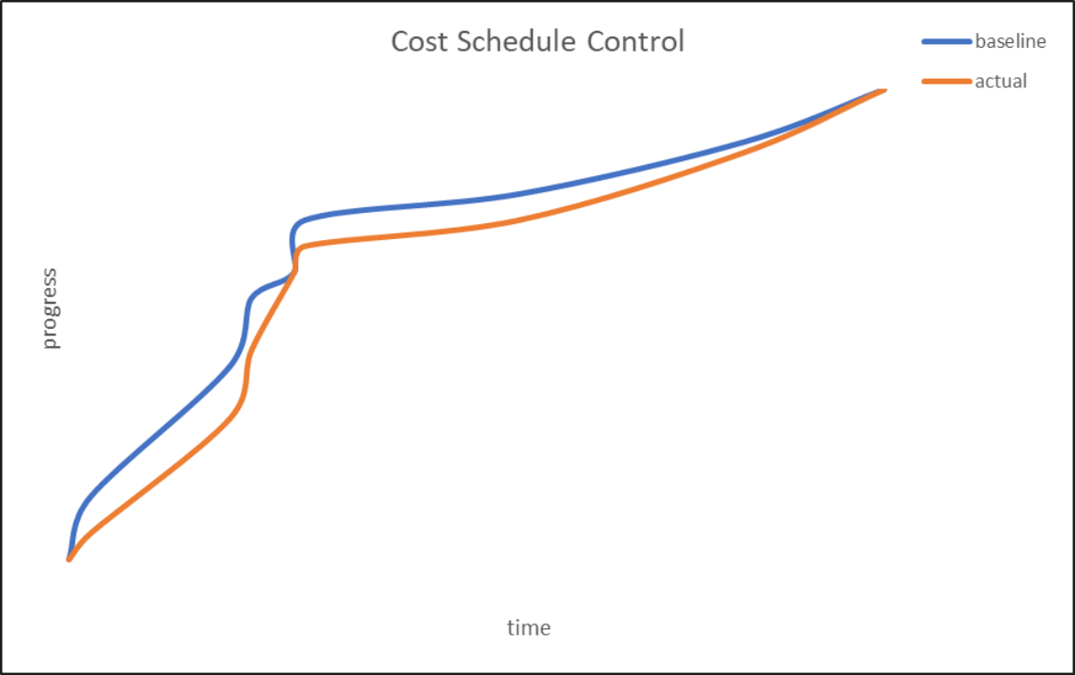

Figure 13 Project cost control chart

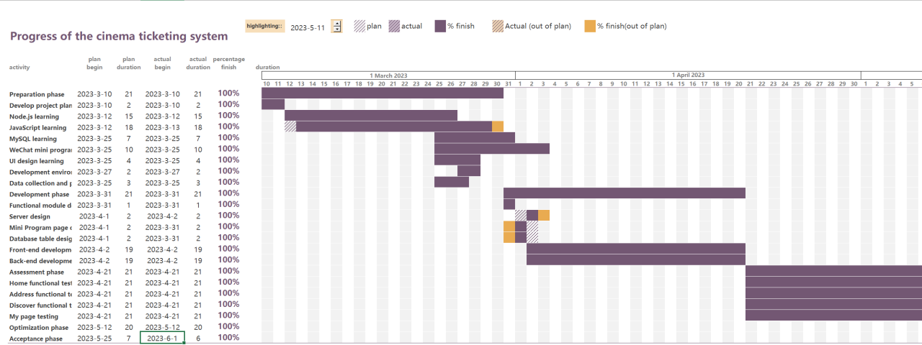

Figure 14 Gantt chart

**7. Summary**

This semester, through the study of software project management courses, we have gained a preliminary understanding of the knowledge system and architecture of project management. The cinema management system requires effective software project management to ensure the smooth completion of the project. It combines industry characteristics and utilizes project management techniques, concepts, and methods, covering multiple knowledge areas such as time management, cost management, quality management, risk management, human resource management, communication and exchange management, etc. Here is our summary of project management for this project:

Define project objectives and requirements: Before the project starts, we have clearly defined the project objectives and requirements, including requirements for project functionality, time, and budget.

Dividing project stages and tasks: We divide the entire project into multiple stages and assign specific tasks and timelines for each stage, so that our team members can understand the progress of the project and complete tasks on time.

Determine the project team: After the project starts, the project manager determines the team members and their respective responsibilities based on the project requirements and tasks, ensuring that the professional skills of the team members match the project requirements.

Assign work and track progress: Our project manager assigns tasks to different team members and monitors their work progress, promptly identifies problems and takes measures to solve them,

Risk management: During the project execution process, we will supervise each other to ensure timely identification and evaluation of potential risks, and take measures to prevent or reduce the impact of risks.

Communication and coordination: During the project execution process, our team members maintain good communication and coordination. Solve problems promptly when they are discovered. Ensure the efficiency and quality of the entire team's collaboration.

Testing and Acceptance: In the end, for the software system developed in the project, we conduct testing and acceptance to ensure that it meets the specification requirements and as much as possible meets the standards of the initial plan and user expectations.

Through the study of this course this semester, we have gained a lot. While learning theoretical knowledge, we have also started to practice. However, to truly learn project management well, we need to constantly practice, learn skills, and summarize experience. In daily life, we need to speculate and deeply experience the knowledge we have learned, and truly apply it to our studies and work, achieving the goal of applying what we have learned. Through the experience of software project management in cinema management systems, we can learn many valuable lessons, such as clarifying project goals and planning project timelines reasonably. Otherwise, if everyone's identity and responsibilities are not clear, there is a possibility that the project cannot be completed on time. In future project management, we will carefully summarize experiences and lessons learned, continuously improve and improve management methods to improve project success rate and quality.